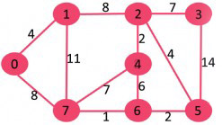

After sorting:

Source Destination Weight

7 6 1

4 2 2

6 5 2

0 1 4

2 5 4

4 6 4

2 3 7

7 4 7

0 7 8

1 2 8

1 7 11

3 5 14

Now pick all edges one by one from sorted list of edges  
**1.** Pick edge 7-6: No cycle is formed, include it.



**2.** Pick edge 4-2: No cycle is formed, include it

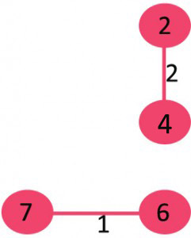

**3.** Pick edge 6-5: No cycle is formed, include it.

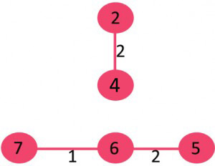

**4.** Pick edge 0-1: No cycle is formed, include it.  
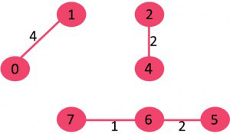

**5.** Pick edge 2-5: No cycle is formed, include it.  
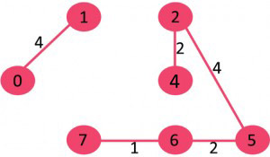

**6.** Pick edge 4-6: Since including this edge results in cycle, discard it.

**7.** Pick edge 2-3: No cycle is formed, include it.

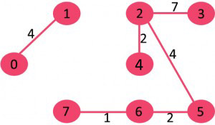

**8.** Pick edge 7-4: Since including this edge results in cycle, discard it.

**9.** Pick edge 0-7: No cycle is formed, include it.

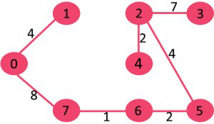

Since the number of edges included equals (V – 1), the algorithm stops here.